Response to the Reviewers’ Comments for TPEL-RegAP-2026-02-0431
Manuscript Title: Design and Implementation of a Non-coupled Integrated Transformer for a Two-phase Interleaved Flyback PFC Rectifier

Aug xx, 2026
Dear Editor,
We would like to express our sincere appreciation to the reviewers for their constructive and insightful comments on our manuscript. The manuscript was revised in accordance with point-by-point answers to all the questions and suggestions.
- Pages 2 to 14 correspond to Reviewer #1’s comments.
- Pages 15 to 21 correspond to Reviewer #2’s comments.
- Pages 22 to 30 correspond to Reviewer #3’s comments.
We conducted additional simulations and experiments and revised the manuscript accordingly. In particular, we strengthened the literature review, clarified the new contributions beyond the conference version, and added additional frequency-domain characterization and thermal evaluation. We also updated the manuscript to improve clarity, consistency, and figure/table referencing based on the reviewers’ suggestions.
We hope the manuscript is now acceptable for publication.

Best Regards,
Sihoon Choi
Corresponding author,
Institute of Materials and Systems for Sustainability, Nagoya University
Email: choi.sihoon.w4@f.mail.nagoya-u.ac.jp

To Reviewer 1
We authors appreciate your valuable comments. The revised parts are indicated by red texts in the manuscript.

Comments to the Author
The manuscript presents a study of an interleaved flyback topology that employs a single transformer shared between the phases. The proposed approach is interesting, and the presented results demonstrate a reduction in magnetic component size compared to conventional solutions. However, several important technical aspects are not adequately addressed, making it difficult to assess the technique's actual superiority and practical benefits. Although a standard EE core is employed, the windings are distributed across all three legs of the magnetic core. This arrangement may complicate large-scale manufacturing, increasing production costs and assembly complexity. Furthermore, important technical aspects, such as the impact on leakage inductance, are not discussed and require further clarification. The following comments are provided to improve the manuscript:
1) Leakage inductance is a critical issue in flyback converters, significantly affecting efficiency, power density, voltage stress, and overall converter performance. Due to the proposed winding arrangement, in which the primary and secondary windings do not appear to be fully overlapped, leakage flux may increase compared to conventional transformer designs. A detailed study quantifying the impact of the proposed winding configuration on leakage inductance is necessary for a proper evaluation of the proposed solution.
Thank you for your comments. In reality, when winding this transformer, the windings are overlapped to reduce leakage as much as possible. The figures shown about the transformer is just a representation of the general winding structure.
Moreover, this overlapping resulted in a coupling coefficient of 0.970 for transformer N₁₂ – N₃₄ and 0.979 for transformer N₅₆ – N₇₈. We anticipate that these values can be further improved when utilizing automated, industrial-grade manufacturing techniques. We have updated [Section X] of the revised manuscript to clarify the physical winding implementation.

2) No efficiency measurements are presented in the manuscript. Efficiency is a key performance indicator and is essential for assessing the effectiveness of the proposed topology. Experimental efficiency results over a range of output power levels should be included.
Thank you for your comments. We have included an efficiency curve as shown below. The text in section V has been revised to include discussion about this.


3) A comprehensive comparison with a conventional interleaved flyback solution is needed. Key performance indicators such as magnetic volume, efficiency, power losses, current ripple, and THD should be compared to substantiate the claimed advantages of the proposed approach.
Thank you for the insight. Because the primary contribution of this paper is the introduction of the novel integrated magnetic component, our analysis focuses heavily on the reduction of magnetic volume and the independent operation of the interleaved phases without magnetic interference. As detailed in Section IV, our volume analysis using the area product (AP) method demonstrates that the proposed integrated transformer achieves an estimated 56% volume reduction (from 21106.38 mm³ to 9398.46 mm³) compared to its conventional discrete counterpart. Moreover, due to the decoupling offered, the flyback can be operated with single-phase drive, allowing for further advancements in light load efficiency. Because the fundamental discontinuous conduction mode (DCM) operation of the proposed flyback rectifier remains identical to that of a conventional interleaved flyback converter, key electrical parameters such as current ripple and THD are theoretically unaffected by the shared core structure. We have added a clarifying statement in the revised manuscript to explicitly define the scope of our comparison.

4) Experimental load transient results should be provided to demonstrate the dynamic performance of the converter and to verify the claimed decoupling between phases under transient operating conditions.
Thank you for this suggestion. The proposed two-phase interleaved flyback rectifier preserves the fundamental control and operational principles of a conventional discrete flyback topology. Therefore, we expect that the dynamic performance remains largely unchanged.

The primary contribution of our integrated transformer is the structural decoupling of the magnetic flux paths within a single EE-core, which we successfully verified in steady-state operations up to 240 W, achieving a negligible inter-phase coupling coefficient of 0.0005. Because the flux paths remain orthogonal and geometrically isolated, this decoupling inherently extends to transient states. We have expanded our discussion in the revised manuscript to explicitly address the transient behavior and confirm the robust decoupling capability under dynamic conditions.

5) A photograph of the experimental prototype, including identification of the main components, should be included. This information is important for evaluating the practical implementation, overall size, and power density of the proposed converter.
Thank you for your comments. We have added a photograph of the experimental prototype to the revised manuscript to provide a better perspective on the implementation, footprint, and power density. Because the hand-wound nature of the custom integrated transformer makes it challenging to visually distinguish the individual windings from the photo alone, we have also included an accompanying structural diagram (Fig. 13b). This diagram clearly identifies the main components and winding locations.
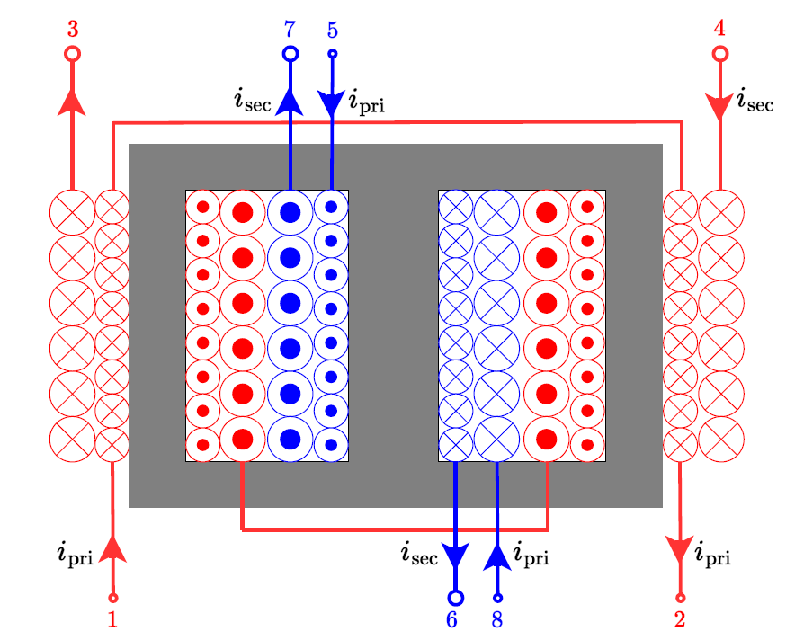

6) A detailed loss breakdown should be presented, particularly for the transformer, which is the main contribution of the work. The analysis should be accompanied by a comparison with a conventional interleaved flyback implementation to highlight better the advantages and trade-offs of the proposed magnetic structure.
The proposed approach consolidates two discrete magnetic components into a single shared EE-core. By reducing the total estimated core volume by 56%, the overall core losses are inherently reduced compared to a conventional implementation using two separate transformers, due to the implementation of flux cancellation.

I’m performing theoretical analysis of core loss using iGSE. For the winding losses, I’m still thinking (or, is it still important?)

To Reviewer 2
We authors appreciate your valuable comments. The revised parts are indicated by red texts in the manuscript.
Comments to the Author
Although the paper extends the concept presented in the conference version, the explanations are presented in a vague and unclear manner, making the technical content difficult to follow and understand.
1. What is the voltage across capacitor Cin? Please provide an analytical expression and discuss its variation under different operating conditions. Also check the presence of Cin in Fig.1©.

Thank you for the comment. The capacitor C_{in} acts as the decoupling capacitor placed immediately after the input bridge diode. Therefore, the voltage across $C_{in}$ is the rectified AC line voltage, given analytically by $v_{in}\left(t\right)=V_{in_{max}}|\sin\left(2πf_{line}t\right)|$. Under variable load conditions, the peak voltage $V_{in_{max}}$ remains dictated by the AC main voltage.

We also apologize for the error in Fig. 1(c). We have updated Fig. 1(c) in the revised manuscript to include the input capacitor for consistency with the detailed topology shown in Fig. 2(a).

2. Please explain how variations in input voltage affect the magnetic flux density and switch current stresses. A detailed theoretical analysis would improve understanding.
Thank you for the comments. Equations detailing the magnetic flux density and switch current are as shown in Eq. (2) and (3) for the first active phase, and in Eq. (4) and (5) for the second active phase in Section II-A. The peak switch currents $i_{S_{1_{pk}}}$, $i_{S_{2_{pk}}}$ and peak flux densities $B_{o_{pk}}^{'}$ (will complete in next version) are directly proportional to the instantaneous input voltage $V_{in}$. Because the converter operates as a PFC rectifier, $V_{in}$ follows a rectified sinusoidal envelope. Consequently, the switch current stress and the peak flux density also vary sinusoidally over the line cycle, reaching their maximum values at the peak of the AC line voltage ($V_{in_{max}}$). We have added a dedicated paragraph in [Section X] detailing these operational dynamics.

3. The duty cycle is not adequately defined in the manuscript.
Thank you for your comments. As we explained in the manuscript, the duty cycle D affects how fast the stored energy in the magnetizing inductance of each transformer is discharged in each phase.

In terms of the open-loop control scheme for this study, we have explicitly referenced Equation (28), which defines the duty cycle D in terms of the output power $P_{o}$, switching period $T_{s}$, peak input voltage $V_{in_{max}}$, and magnetizing inductance $L_{m}$. This was chosen as the reference operates in the same principle as this flyback.

4. How is power factor correction (PFC) achieved or ensured in the proposed converter? Please provide supporting analysis and experimental verification. The PFC control methodology is not clearly described.
Thank you for your comments. The proposed flyback rectifier operates in Discontinuous Conduction Mode (DCM). In such a topology, PFC is naturally achieved even without a dedicated, complex current-shaping controller. Because the converter operates with a fixed switching frequency and a constant duty cycle $D$ over the AC line half-cycle, the average inductor current in each switching period is directly proportional to the instantaneous input voltage with no phase shift. As a result, the average input current naturally follows the sinusoidal shape of the AC input voltage, achieving high power factor in open-loop control. Some equations are shown below that explain this phenomenon.

5. The experimental results are not sufficiently clear for readers to fully understand the converter operation. Consider improving waveform quality and adding more detailed explanations.
Thank you for your comments. We agree that the experimental waveforms needed improvement. We have revised the figures to remove cluttered annotations.

6. Significant ringing is observed during the switching transitions of S1 and S2. Please explain the cause of this oscillation and discuss possible mitigation methods.
7. A persistent oscillation is visible in the Vds1 waveform. Please provide a detailed explanation of its origin and impact on converter performance.
Thank you for your comments. We address the two questions above together as they are related to the same phenomenon. The ringing observed during the turn-off transitions of S₁ and S₂, as well as the persistent oscillation in v_{ds1} and v_{ds2}, originates from the resonance between the transformer's leakage inductance and the parasitic output capacitance (C_{oss}) of the switches. This is a well-known characteristic of flyback converters operating in DCM. When the secondary diode current reaches zero, the magnetizing inductance also resonates with the C_{oss}, causing the characteristic low-frequency ringing seen on $v_{ds1}$ before the next switching cycle begins. The portion of the manuscript in Section V has been revised to reflect this explanation. To mitigate this, we added RCD snubbers $C_{sn}$, $D_{sn}$, $R_{sn}$ as shown in Fig. 10(a). To further improve efficiency, it is essential to improve snubber quality as well, but it is not the focus of our study….

8. A photograph of the hardware prototype would be helpful. Furthermore, if a comparison with existing solutions is claimed, the corresponding experimental setup and hardware implementation should be clearly presented.
Thank you for your comment. We have added a photograph of the hardware prototype in Figure xx, alongside a structural diagram to clearly identify the custom integrated transformer and main circuit components.

9. The manuscript should include a comprehensive comparison with relevant published literature to clearly demonstrate the advantages and unique contributions of the proposed approach.
Thank you for your comment. In addition to the literature stated, we have summarized the advantages of our proposed approach to decoupled interleaved operation in a newly added table Table xx. This table clearly contrasts our non-coupled integrated transformer against conventional discrete solutions and […] methods, explicitly highlighting our advantages in core volume reduction and decoupled transient operation.

10. The explanation of the flux cancellation phenomenon is insufficient. Please provide a more rigorous theoretical analysis and supporting evidence. It would be beneficial to illustrate the magnetic flux path during each operating mode, all six modes as explained for working. Such diagrams would significantly improve clarity and reader understanding. (Why the flux in central limb is zero during mode1-3? It may zero for N12,34. Will there any flux present because of N56,78?)
Thank you for the comment. Thank you for pointing out the need for deeper clarification. The flux in the center leg during Modes 1-3 is indeed zero. During these modes, only the $N_{12}-N_{34}$ transformer is active. As shown in the equivalent magnetic circuit in Fig. 6(a), the fluxes generated by the two outer legs are equal in magnitude but opposite in direction through the center leg, causing perfect flux cancellation. Furthermore, during Modes 1-3, the $N_{56}-N_{78}$ transformer is entirely inactive (both primary and secondary currents are zero). Because no current flows through the $N_{56}-N_{78}$ windings, no magnetomotive force (MMF) is generated in the center leg. Central to this principle is the fact that two transformers are completely decoupled, causing no current to flow in the transformer of the inactive phase. We have revised the explanation of this principle more in Section II…

11. If, Mode1,2,3 are for +ve half cycle and mode 4,5, 6 are for negetive half cycle then can we represent the B01′ and B01′′ in the same time line graph??(Ref: Fig:4) Its difficult to understand.
Thank you for your comment. We apologize for the confusing terminology in the manuscript. The terms “positive” and “negative” cycle were chosen to describe the high-frequency interleaved switching phases, inadvertently implying AC line-frequency half-cycles. In reality, the two phases operate 180$°$ out of phase within the same $T_{s}$, meaning that they function in the same timeline.

The reason for separating the graphs in Fig. 4 is to merely denote which flux component (B’ or B’’) is generated by which specific transformer phase (Phase 1 or Phase 2) before they are super-positioned in the core. We have rigorously revised the terminology in Section two, replacing "positive/negative AC input" with "Phase 1 active period" and "Phase 2 active period," and added a clarifying note to Fig. 4 to explain the timeline mapping.

12. Some portions of the manuscript appear repetitive. The presentation could be improved by consolidating overlapping discussions and avoiding redundancy.

13. Please provide a more detailed explanation of the mechanism by which the proposed topology improves light-load efficiency. Quantitative results would strengthen the discussion.
This behavior is expected already for

14. Strengthen the litreture survey and refrences.
Thank you very much for your comment. Please see the response to Question 9.

To Reviewer 3
We authors appreciate your valuable comments. The revised parts are indicated by red texts in the manuscript.
Comments to the Author
This paper analyzes the design and implementation of an interleaved Flyback converter based on magnetic integration. My comments are as follows:
(1) The efficiency of the converter is a very important indicator. The paper should include the efficiency curve of the converter, as well as the efficiency comparison with the interleaved Flyback converter without magnetic integration, and also the efficiency comparison analysis with other similar converters.
Thank you for your comments. We believe that the converter efficiency will not change whether

(2) The modulation results of the interleaved converter are not mentioned in the paper, especially the experimental results.
Thank you for your comments. The experimental tests for this prototype were performed using open-loop control (fixed duty cycle) to strictly isolate and verify the fundamental magnetic decoupling of the proposed transformer structure. Because the focus of this paper is the magnetic component itself, with the fundamental electrical operation of the flyback unchanged from the conventional setup, standard closed-loop modulation and control schemes can be directly applied without modification. Therefore, we did not include specific closed-loop modulation results. We have added a clarifying note in section xx of the manuscript to better explain the scope of our experimental verification.

(3) The volume advantage brought by magnetic integration needs to be further explained, and the benefits brought by magnetic integration should be explained by comparison.
Thank you for your comments. We found an advantage in terms of core losses. Please see the response to Reviewer #1 (Comment #6)

(4) As a PFC, more experimental waveforms need to be provided, including the operating condition where the power factor is not 1, the dynamic waveform of the output voltage, etc.
Thank you for your comments. However, as this two-phase Interleaved Flyback PFC operates in DCM, then PFC occurs naturally. We have shown the derivation in the comment by Reviewer 2 (Comment # 4).

(5) Photos of the experimental prototype need to be shown in the paper.
Thank you for your comments. The experimental prototype is shown in Figure xx. Please see the comment from Reviewer 1 (Comment #5) for more details.
- End of the response letter

Our flyback has same operational principles with the flyback. Flyback has PFC function with DCM. r –

THD

Not aggressive mode. PFC can automatically occur. THD is not our interest. Nromally, nit is THD regulation like PFC . It also depends on the input filter. It depends on the input filter so its not fiar application for this research. Because we didn’t prepare input filter. But anyway, it can be achieved like PFC. Anyways its sasme with cnvetional flyback.

In terms fo transformer, we can’t do some experiment, we need to explain qualitatively clearly . normal two separate transformer, an our preoposed one..

It our case we have flux cancellation. It might be hard to quantify, we can …. They must have something they can understand. Even though we don’t show it, we have tried to efficienc of the proposed rectifier. It is slightly higher it usually ranges from lower to higher. We confirmed our one,

Snubber?

Maybe you can add some efficiency

Qualtiitave.

